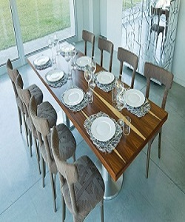

Dining Table

$143.79

Availability: In stock

Description

The Edra Furniture Collection Dining table is uniquely designed to impress and be added to your home it features wood rectangular shaped table and steel legs Made of high quality materials it most rates delicate craftsmanship.